Create a .dat Flat File With Excel Loader

Description
This job aid describes how to create a .dat file in the Excel Loader flat file creation tool. It was designed with a macro that creates a flat file in the required fixed-length format. The eSettlements Flat File Loader template is available in the MSupplier Portal at http://procurement.umich.edu/supplier-resources/supplier-portal/electronic-settlements > MSupplier: Enablement Documents.

Important
To create the .dat file, you must have a C:\TEMP folder on your computer and Microsoft Office 2007 or later.
Excel Loader File  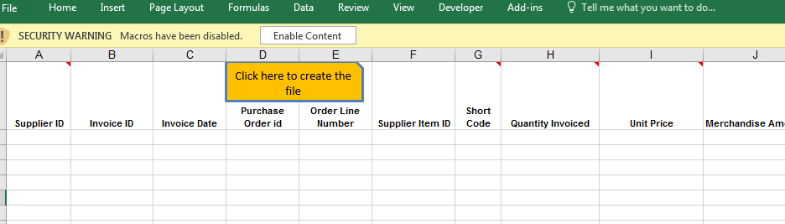  1 | Note: Open the Excel Loader file. It gives you security warning that Macros have been disabled. Make sure they are enabled.  - Click Enable Content

Excel Loader File  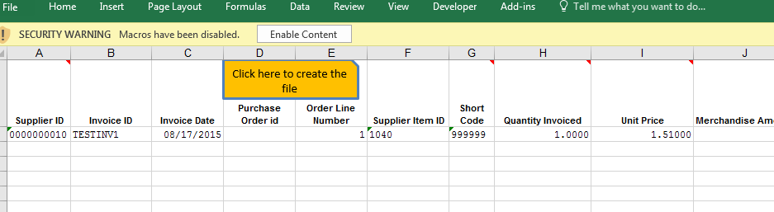  2 | Populate the worksheet with the invoice or credit memo data you would like to submit to the University of Michigan. Save the file.  - Click the Click here to create the file macro button.  Note:  - The macro validates the data for format errors and required fields. All errors must be fixed before the *.dat file can be created.  - If the supplier ID number is included, ensure that all lines are populated with the same supplier ID.

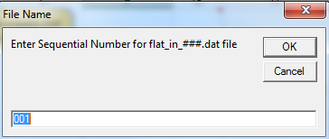  3 | - In the File Name window, type a 3-digit file identifier.  Click OK.

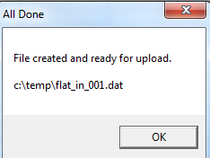  4 | - In the All Done pop-up window, click OK. The fixed length formatted file is created in your C:\TEMP folder. You may then rename the file to include your supplier name and date.  Note: You cannot upload a file with the same file name as a previously uploaded file. It is recommended that you rename your .dat file as follows: SUPPLIERNAME_DATE_SEQNO.dat. Example: hasbro_20100324_001.dat  (File names cannot be longer than 50 characters)

