**Account Information**

**New Shred Service Request Form**

| Iron Mountain Customer ID# | 7364X |
| --- | --- |
| Division # or Name (leave blank) | N/A |
| *New Department ID# (Enter Short Code Here) |  |
| **Department Name (be specific)  (Format = ShortCode, Department Name) |  |
| Service Address (Street #, Street Name, Room/Suite/Location) |  |
| Primary Contact Information (First and last name of the primary contact person. Also include in the authorized users below) |  |
| Container Type Model Requested (See page 2 below) |  |
| Number of Containers |  |
| Service Frequency (Weekly, Monthly, One-time service) |  |
| Notes/Comments: |  |

**Authorized Users**

| **Name** (first and last) | **Direct Phone #** | **E-mail address** |
| --- | --- | --- |
|  |  |  |
|  |  |  |
|  |  |  |
|  |  |  |
|  |  |  |
|  |  |  |
|  |  |  |

• Please forward your completed form or any questions to: askcustomerservice@ironmountain.com and copy tamany.swackhamer@ironmountain.com

• If you have any questions please email Tamany Swackhamer at Iron Mountain –

tamany.swackhamer@ironmountain.com

*Iron Mountain uses the Short Code as the department ID in their system. Do not provide you actual department ID.

**Department name must be in the below format:

Short code, Department name: XXXXXX, DEPARTMENT NAME

***Iron Mountain Shred Containers***

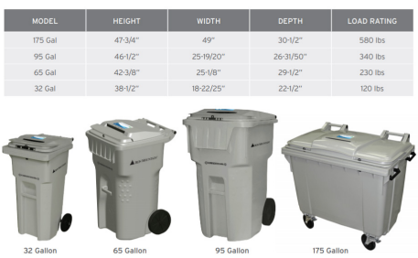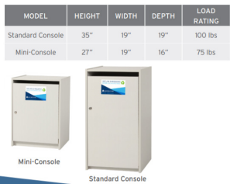

*Bin prices are per bin, per service and will include additional charges for fuel and transportation.*